Mishka’s Engine

A 2D RPG/Text Adventure

game engine

By Mishka

Engine
The game engine (game on linux, game.exe on windows) will auto-execute data/main.gs when started unless a different file is specified on the command line. For information on scripting see GS Reference below.
Currently the engine supports bitmap formatted images although the image loading function is abstracted in a header and will probably be integrated with FreeImage for loading all image file types. Magic pink (#FF00FF) is treated as transparent in all images except those loaded with Background or Splash.
Tilesets are always 512x2048 pixels internally but smaller or larger images can be loaded and will clip to the correct dimensions. This is also true of sprites, where the image will be clipped to the dimensions that you specify in your script.
Tilemaps are created with edit2 (see Edit2 Reference), and are in a custom format. Most of the header is there for future use when I might support dynamically sized maps and such without breaking compatibility with old maps, but currently everything is just hard-coded.

Currently in the code tiles are treated as 16x16 pixels although the intention is to treat tiles as if they were 32x32, and the ability to place smaller tiles as having quarter-tiles. This also allows more fine-grain collision maps.

GS Reference

This is a reference for all of the operators available in the GS “Language” (Not sure I would actually call it a language, its pretty meh but it works).
There are no real formatting rules, comments start with a // and arguments to operators are separated by spaces. Strings are enclosed in double quotes. Anything encapsulated in %% is substituted with the value of the variable. If you don’t want to have spaces you can make it a string literal.
Variables are loose-typed, and can be substituted in place of almost any section of code. Variable names (And infact anything) can be enclosed in a string literal too.

Basic operators

Print String
Print String to the screen, not super useful for games but good for debugging.

If var1 [=,!=,<,>] var2 .. Endif
Execute the following code block only if the statement is true. Does not parse any complicated expressions, simply checks var1 and var2 using the selected operator. There is no else, if the statement is not true then execution will move to the next Endif.

Set a [=,+=,-=,*=,/=] b
Set variable a depending on the operator, either setting it to b or: adding b, subtracting b, multiplying by b, or dividing by b respectively.

Random var min_val max_val
Set var to a random value between min_val and max_val.

Goto label
Start executing from label, labels should start with a colon and be on their own line, e.g. “:labelname”.

GoSub label
This is the same as Goto except that the current execution point is remembered and can be recalled using Return. These statements cannot be nested, and attempting to do so will result in a “GoSub inside GoSub” error.

Return
Execution will resume from the previous GoSub statement.

Dump filename
The code as parsed by the preprocessor will be re-written to one file. The new file will not have comments, indentations, or any pre-processor statements.

SaveStack filename
Save all variables to a text file for debugging or loading later on.

LoadStack filename
Load a file saved with SaveStack.

Sleep time
Pause execution for time milliseconds.

Quit
The program will quit.

End
The script will stop executing and the program that initiated the script will begin running again. In the game engine this currently also results in the same behaviour as Quit.

Preprocessor operators

Include filename
The specified file will be loaded and parsed as if it were part of the current file, inserted in the same location as the include statement.

For iterator from to .. Next
Creates a For .. Next loop using iterator as the iterator variable, counting form from to to in increments of 1. This will insert code into the pre-processed buffer.

Graphics operators

Splash filename
Load and display a file to use as a background or splash screen.

LoadTileMap filename
Load a map from the specified file (see editor documentation).

LoadTileSet filename
Load an image to use as the tileset for any loaded map. If you load the tileset after loading the map you need to use RefreshTiles to update the world.

RefreshTiles
Redraw the map.

SetTile x y z tID [SOLID|CLEAR]
Set the tile at the given coordinates to a certain ID, and set it to be solid or not.

Trigger x y label
Set a trigger to execute when the player steps on this tile. Will execute label when the trigger is activated. If flag F3 is set in the editor the player must press interact (see controls.bi for keybinds) for the trigger to execute.

ActionTrigger label
Set a trigger to execute when the player presses action/attack (see controls.bi for keybinds).
Player Sprite filename imagewidth framesize animations
Load an image to use as a sprite for the player.

Player Position x y
Set the player’s position on the map.

Player Zindex z
Set which layer the player is drawn on top of (For more on layers see the editor documentation).

Player Speed speed
Set the player walk speed.

Player DisableInput
Disable player input (useful for cutscenes etc.)

Player EnableInput
Re-enable player input. Input is enabled by default.

Player SimpleCollision
Collision with solid tiles is from the centre of the sprite.

Player FullCollision
Collision with solid tiles is from the edges of the sprite image.

Light Set filename imagewidth imageheight
Load a black and white mask image to use as a lighting overlay centred on the player.

Light Radius radius
Generate an image internally to use as a mask image for lighting.

Light Delete
Delete any loaded lighting mask.
Object Clear
Clear all objects.

Object Add var filename imagewidth framesize animations
Load a sprite image similarly to the player sprite, however var stores the array index of the object for future reference using the functions below.

Object Set id filename imagewidth framesize animations
Load a sprite image into an already existing object.

Object Trigger_playerAction id label
Execute from label if the player presses action whilst touching the specified object.

Object Trigger_playerTouch id label
Execute from label if the player touches the object.

Object Trigger_MovementEnd id label
When the object has finished moving (using Object MoveTo), execute from label.

Object Pos id x y
Immediately set the object to the specified position.

Object MoveTo id x y
Make the object “walk” in a straight line to the specified position.

Object Speed id speed
Set the object’s “walk speed” similarly to the player’s.

Object Disable id
Disable the object, it wont be drawn and triggers wont be processed.

Object Enable id
Re-enable a disabled object.

Object Animate id
Make the object animate at all times.

Object NoAnimate id
The object should only animate when moving.

RunGame/ResumeGame
Enter the main game execution loop, where player inputs are processed and triggers will be executed.

Text and menu operators

TextSpeed delay
Set the delay time between printing each character in dialogue boxes.

Dialogue String [false]
Show a dialogue box and wait for the player to press continue. If false is specified then the player does not need to press continue, execution will continue instantly instead.

Transisiton [FADE|BLINDS]
Draw a transition to black.

Confirm message label
Ask the player a yes/no question and jump to label if the player selects yes.

Option Add label text
Add an option to be selected by the user from a menu, execution will move to label if the user selects this option.

Option Select
Pick from added options, and then clear all options.

Background filename
Load an image to the screen.

Edit2 Reference
Edit2 is the replacement for the keyboard-shortcut only editor that I created when I first started the project. It now has a GUI and some shortcut keys as well as some new features.
To launch the editor, run edit2 or edit2.exe depending on your platform. The command line arguments are:
edit2 <tileset image> <tilemap file>
Although you can load files from the editor this may be easier. If no files are specified nothing will be loaded, or you can specify only a tileset and choose a path for your tilemap later.

GUI
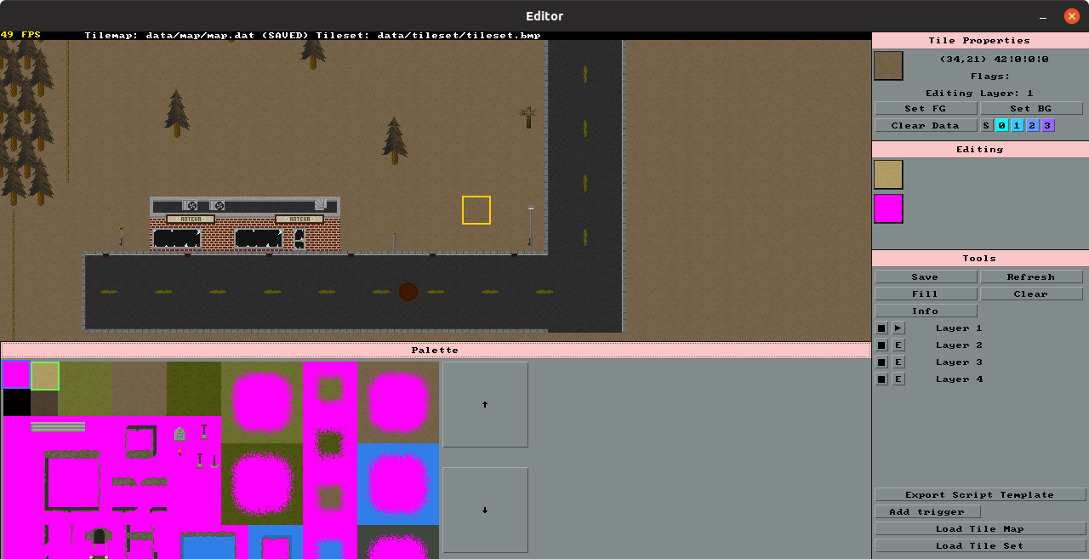

The GUI is divided into several sections which are listed below.

Tile properties
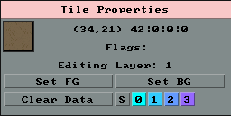
The tile properties window shows information about the currently selected map tile (shown with a yellow selection box).
The 32x32 version of the selected tile is shown, along with the selection coordinates. The numbers next to the coordinates show the tile ID of each layer under the selected tile. When the tile is larger than the minimum size the displayed information correlates to the top left tile of the selection.
The next section shows any flags that are set on the tile, which mirror the flag buttons below (S = Solid, then F0...F3 flags). The flag buttons set all selected tiles flags, holding control and clicking the flag buttons will only set the top left tile of the selection as if the selection size were at it’s smallest.
Set FG will set the current palette foreground tile to the ID matching the selected map tile. Set FG does the same for the background palette tile. This allows setting which tile to paint with without searching the palette.
Clear data will erase all flags.
Editing
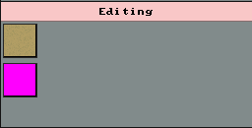
The editing window currently shows the 32x32 version of the selected palette tiles. In the future it will contain more information and perhaps copy/paste abilities.

Tools
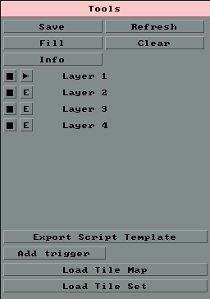
The tools window contains many core tools, including layer controls and file operations.
The save button will save the current file, at present the message “Saved probably (0)” will be displayed. The number in brackets is the runtime error code of the file operation, if the number is 0 then saving was successful. The code does not check this value, hence the message.
Refresh will re-draw the tilemap incase it was not refreshed correctly for some reason.
Fill and clear will fill or clear the selected layer. Clear will always default to tile ID 0 so this tile should always be something sensible like transparent or black. Fill uses the current foreground tile selection.
Info will toggle the debug information which is drawn on the top layer, so hiding that layer will also disable that information. This debug layer will show solid tiles and flags. (See editor window).
Below this are the layer controls, with the visibility toggle button ( / ) which will show or hide a layer, and the edit select button ( / ) which will select the layer to edit.
The load buttons will prompt for a path. If a path is specified and Cancel is not selected then the file will be loaded.
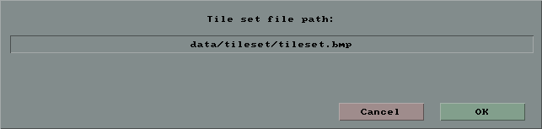
Add trigger will set a trigger on the currently selected tiles, however this setting is not persistent and is simply meant for creating a template script with the “Export Script Template” button. This will generate a script file that can be used as a template for the current map.
Palette
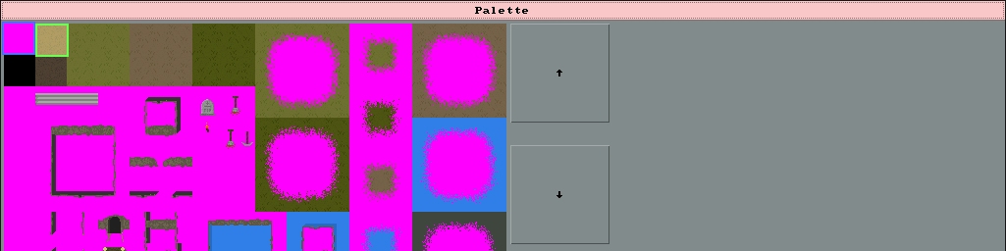
The palette window shows the tileset and allows choosing a tile to place. The blue selection is the “background tile” and the green selection is the “foreground” tile. Clicking on a tile selects it. The arrow buttons allow scrolling down the tileset to see more tiles. To change the selection size, the hotkeys “[“ and “]” can be used. The default is 32x32, the minimum is 16x16.

Edit Area
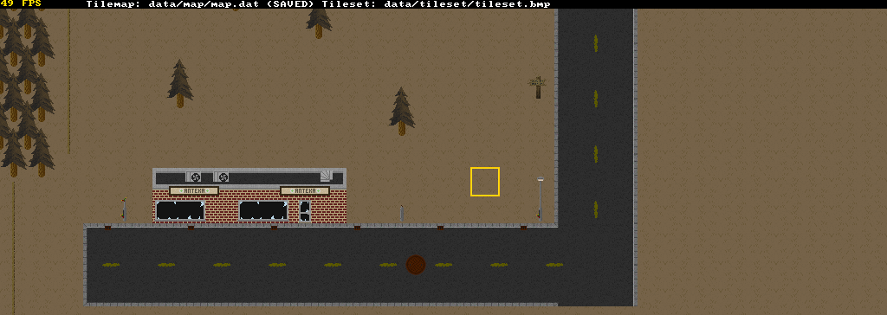
The edit area shows the map. The currently selected area, shown with a yellow box, can be changed by clicking, if clicking whilst holding Control the tile will be set to the foreground tile (left click) or the background tile (right click) as selected below in the Palette window.
Holding Alt and Clicking will allow scrolling the map, the behaviour of this scrolling is a little strange but gets the job done. When scrolling near the extents of the map it will snap to the edges.
At the top there is a title bar showing if the file has been saved, which files are used for editing and the current framerate.
Quitting without saving results in a warning.

Unsaved changes warning
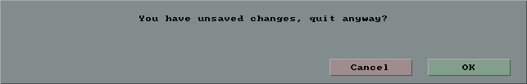
Debug Info
